RUH.AI
V1 Design Partner Pilot Blueprint
& Rollout Runbook
A repeatable deployment playbook for proving digital employees with real customers, using packs, tenant overlays, approvals, and measured phase gates.
Applies to: Construction Project Operations + AI BuildOps reference packs
Audience: Product, engineering, implementation, customer success, design partners
Status: Working v1 execution document
What this document answers
• Which customers qualify for a design-partner pilot and what must be true before kickoff.
• How a pilot moves from monitor mode to draft mode, approval mode, and constrained autonomy.
• Which metrics, roles, artifacts, and gate reviews determine pilot success and production expansion.

1. Purpose of this document
The previous documents define the platform. This one defines the path to prove it with real customers.

This blueprint converts the Ruh.ai product stack into an executable customer deployment model. It assumes the platform PRD, system design, API/event contracts, employee pack specification, reference pack definitions, and tenant overlay kits already exist. The pilot blueprint is the missing execution layer between product design and production rollout.
Its job is simple: make sure every design partner is qualified consistently, deployed safely, measured against a baseline, and either promoted to production or exited with clean learnings that improve the packs, overlays, and platform.
Qualify  Confirm sponsor, workflow owner, systems of record, baseline metrics, and the trust boundary before work begins. | Deploy  Compile the pack + tenant overlay, connect systems, run shadow mode, and introduce approval-gated write-backs in phases. | Prove  Use a single scorecard for business value, trust, technical health, and adoption before expanding or commercializing.

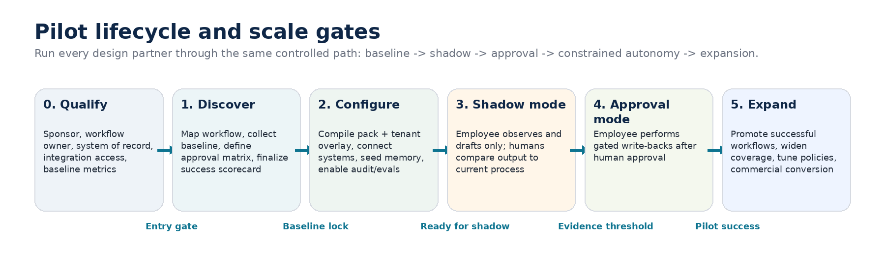
Figure 1. Every pilot follows the same control path and only expands after evidence thresholds are met.
Design rule for v1 pilots
• Start with one or two workflows, not an entire department.
• Keep the customer system of record in the center of the process; Ruh.ai should orchestrate work around it, not replace it.
• The first goal is trust and measurable delta, not maximum autonomy.

2. Pilot principles and scope discipline

1. Prove one narrow problem at a time. A pilot should target a painful, repetitive workflow with enough volume to measure value, but not so much surface area that change management swamps the result.
2. Read first, write later. Every pilot begins with monitor or draft behavior before any system write-backs are enabled.
3. Approvals are part of the product. Human validation is not a workaround; it is the mechanism that creates trust and allows safe promotion to higher autonomy.
4. Measure against a locked baseline. Time saved, turnaround reduction, approval behavior, and task quality must be measured against the customer's current state rather than rough anecdotes.
5. Treat every pilot as a pack-improvement engine. Every exception, false positive, missing permission, and user complaint should convert into a reusable pack or overlay change.

Pilot archetype | Recommended first workflows | Default overlay profile | Primary buyer | Value proof
Construction Project Operations | Meeting prep, action-item chase, RFI or submittal triage | Procore + SharePoint + Teams | Operations leader, PMO, VDC, project controls | Hours saved per project, overdue actions reduced, faster coordination turns
AI BuildOps | Intake triage, spec drafting, release notes, incident follow-up | GitHub + Linear + Slack + Sentry | CTO, VP Engineering, platform or product ops | Cycle time reduction, fewer manual handoffs, faster incident follow-up

3. Customer qualification and entry criteria
Do not start a design-partner pilot unless the customer can complete the minimum operating loop.

Qualification is a product decision, not only a sales decision. Poor-fit pilots consume implementation effort, distort product priorities, and create false negatives. A customer must demonstrate enough process maturity to let Ruh.ai observe work, retrieve context, receive approvals, and write results back into a trusted system.
Criterion | Why it matters | Minimum threshold for pilot start | Weight
Named executive sponsor | Removes ambiguity when priorities or approvals stall | Required | 10
Named workflow owner | Owns current process, approvals, and user feedback | Required | 10
System of record in active use | The employee needs a place to read from and write back to | Required | 10
Integration access | Admin access, API keys, webhook setup, or app install rights are available | Required | 10
Workflow volume | At least one target workflow has enough weekly volume to generate a baseline and a sample set | Required | 8
Approval participants | Specific approvers are assigned before write-back behavior is enabled | Required | 8
Security and IT readiness | Trust boundary, data handling rules, and allowed environments are approved | Required | 10
Baseline metrics available | Current cycle time, manual effort, or backlog levels can be measured | Required | 8
Change appetite | Customer is willing to run shadow mode and give weekly feedback | Required | 6
Champion user group | At least 2-5 users will use the pilot consistently | Strongly preferred | 5
Expansion potential | A second workflow or second team is visible if the pilot succeeds | Preferred | 5

Qualification scoring rule
• Required items are binary: if any required item is missing, the pilot does not start.
• Weighted scoring is used to compare otherwise qualified opportunities and prioritize implementation capacity.
• Low-volume or low-discipline customers may still buy later, but they should not shape the v1 pack and overlay roadmap.

4. Pilot operating model and team responsibilities

Every pilot needs two aligned teams: the customer team that owns the workflow and systems of record, and the Ruh.ai team that configures the pack, overlay, policy gates, and success scorecard. The chart below uses a simple RACI model to reduce confusion during the first 90 days.
Work item | Customer sponsor | Workflow owner | IT/admin | Pilot users | Ruh PM | Impl. lead | Integrations | Support/evals
Pilot charter | A | R | C | I | R | C | I | I
Workflow mapping | I | A/R | C | C | C | R | I | C
Connector setup | I | C | A/R | I | I | C | R | I
Approval matrix | C | A/R | C | I | C | R | I | C
Eval and baseline design | I | C | I | C | C | A | I | R
Weekly scorecard | C | C | I | I | A | R | I | R
Go/no-go gate review | A | R | C | I | R | C | I | C
Incident and rollback response | I | C | C | I | C | A | R | R

Minimum Ruh.ai staffing for a v1 design partner
• One implementation lead who owns timeline, risk tracking, customer coordination, and gate reviews.
• One product manager or product owner who captures exceptions and prioritizes pack and overlay changes.
• Shared integration and support/eval capacity for connector setup, incident triage, and quality measurement.

5. Pilot lifecycle, gates, and deliverables

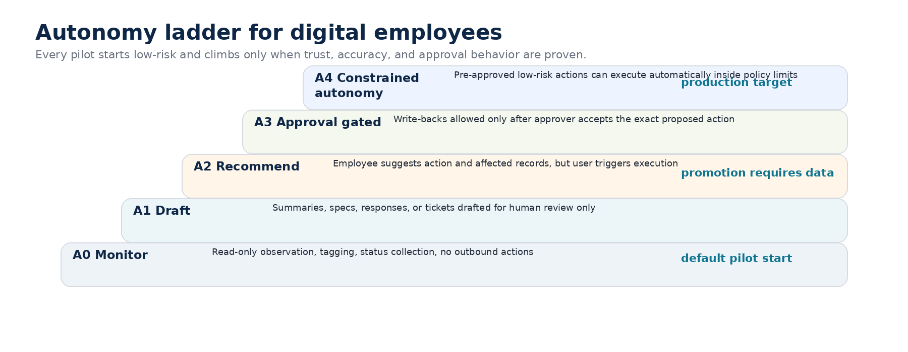
Figure 2. Promotion to higher autonomy is earned through measured behavior, not enabled by default.
Phase 0 - Qualify and charter  Objective: Confirm that the customer, workflow, trust boundary, and baseline data make the pilot worth running.  Key activities: Run readiness assessment, choose the first workflow, define sponsor and workflow owner, and lock the success scorecard.  Exit criteria: Signed pilot charter, target workflow selected, system-of-record access confirmed, and required participants named.  Primary artifacts: Readiness assessment, charter, sponsor map, initial success scorecard. | Gate review questions  • Do we have the right sponsor, owner, and workflow?  • Is there enough volume and access to prove value?  • Would failure teach the roadmap something reusable?

Phase 1 - Discover and baseline  Objective: Capture the live workflow, document the current handoffs, and lock a measurable baseline.  Key activities: Shadow current users, collect example artifacts, classify approval steps, and measure current manual cycle time or effort.  Exit criteria: Workflow map approved, task samples gathered, baseline published, and approval matrix drafted.  Primary artifacts: Workflow map, sample dataset, baseline report, draft approval matrix. | Gate review questions  • Is the current workflow documented with real samples?  • Are the baseline metrics trustworthy?  • Are approval points explicit rather than implied?

Phase 2 - Configure and connect  Objective: Compile the pack and tenant overlay into a customer-specific runtime with connectors, policies, and observability turned on.  Key activities: Provision gateway(s), configure channels, seed memory/context, install connectors, set tool policies, and create initial eval set.  Exit criteria: Dry-run passes, audit logs visible, connector health confirmed, and sandbox or trust-boundary rules verified.  Primary artifacts: Compiled overlay, connector auth matrix, policy bundle, eval seed set, dry-run report. | Gate review questions  • Does the runtime respect the trust boundary?  • Can we observe logs, costs, and connector health?  • Is the system safe to enter shadow mode?

Phase 3 - Shadow mode  Objective: Let the digital employee observe or draft work without changing any system of record.  Key activities: Generate drafts, compare against human output, measure usefulness, collect misses, and tune prompts or pack policies.  Exit criteria: Enough representative tasks completed, acceptance and quality thresholds met, and no unresolved critical trust issues.  Primary artifacts: Shadow scorecards, exception log, tuned templates, shadow gate review. | Gate review questions  • Is draft usefulness high enough to justify write-back risk?  • Are misses explainable and fixable?  • Do users actually engage with the output?

Phase 4 - Approval-gated write-backs  Objective: Allow the employee to perform constrained write-backs after explicit human approval.  Key activities: Enable named approval flows, execute low-risk actions, monitor approval latency, and tune policy restrictions.  Exit criteria: Three consecutive stable reporting periods, no critical policy failures, and clear value against baseline.  Primary artifacts: Approval audit trail, action logs, gate review, conversion recommendation. | Gate review questions  • Are approvals fast enough to preserve workflow value?  • Have action errors and policy violations stayed within tolerance?  • Is business value clearly above baseline?

Phase 5 - Expand or convert  Objective: Move a successful pilot into production scope or expand to the next workflow, team, or autonomy level.  Key activities: Choose expansion lane, finalize support model, package reusable learnings, and agree on production roadmap.  Exit criteria: Production proposal or scale plan approved, support handoff complete, and pilot closeout report signed off.  Primary artifacts: Closeout report, production plan, new overlay delta, next-pack backlog. | Gate review questions  • Which lane creates the best production value: broader users, deeper workflow, or higher autonomy?  • Which learnings must become pack defaults?  • Can support and ownership shift from pilot mode to production mode?

6. Approval model, action classes, and rollback controls

The pilot should make it impossible to confuse model capability with permission to act. The approval model below is the default for v1 unless a stricter customer policy overrides it. Any move toward constrained autonomy should happen only after the pilot has shown stable quality, user trust, and complete auditability.
Action class | Examples | Default pilot mode | Notes
Read-only observation | Status fetch, summarization, tagging, daily digest | Auto | No state change outside Ruh.ai.
Draft creation | RFI draft, issue spec, response template, meeting pack | Human accepts draft | Draft can be discarded with no side effect.
Low-risk write-back | Create ticket, add comment, update status field, append notes | Named approver required | Must show exact payload before execution.
External communication | Send templated message, notify stakeholder, post summary to channel | Named approver required | Only after channel and audience are pre-approved.
Destructive or high-risk action | Delete, close, archive, contract/cost change, customer-facing commitment | Human-only | Out of scope for v1 pilot autonomy.

• Rollback must be immediate and policy-driven: switch the workflow to monitor-only mode, disable write-back permissions, and keep logs intact for root-cause analysis.
• Every phase gate review should nominate a single operator empowered to stop the pilot or drop the workflow back one autonomy level without debate.
• If a trust or quality incident occurs, the platform team should prefer reducing permissions before changing prompts or models.
7. Workstreams and implementation checklist

Workstream | Owned by | Core tasks | Primary output
Pack and workflow config | Ruh.ai product + implementation | Choose employee roster, enable workflow templates, tune prompts and skill settings | Pilot-specific pack delta
Gateway and trust boundary | Ruh.ai implementation + customer IT | Provision gateway, channel bindings, sandbox mode, network and environment separation | Runtime deployment record
Connectors and credentials | Customer IT + Ruh.ai integrations | Install apps, create tokens, map webhooks, test read and write-back paths | Connector auth matrix
Context and memory | Workflow owner + Ruh.ai product | Seed documents, naming conventions, project/repo mappings, reference datasets | Context seed set
Approvals and policy | Workflow owner + sponsor + Ruh.ai product | Name approvers, define action classes, set escalation and rollback rules | Approval matrix
Evals and scorecard | Ruh.ai support/evals + workflow owner | Create baseline, representative task set, quality rubrics, promotion thresholds | Eval suite + scorecard
Adoption and support | Customer champion + Ruh.ai implementation | User onboarding, feedback capture, weekly office hours, incident channel | User enablement kit

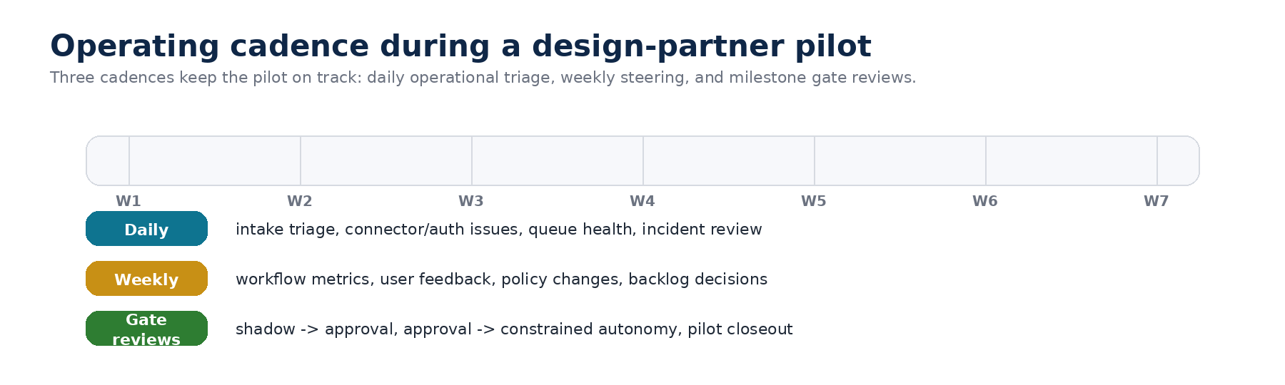
Figure 3. Cadence is part of the pilot design; without regular operating reviews the pack never matures.
8. Scorecard and promotion thresholds

A pilot succeeds only when the scorecard shows that users trust the employee, the workflow improves economically, and the runtime behaves safely and reliably. The scorecard below is the default v1 pattern; each pilot can add pack-specific metrics, but should not remove these four dimensions.
Dimension | Core metrics | Shadow -> approval target | Approval -> expand target | Owner
Business value | Hours saved, task turnaround reduction, overdue backlog reduction | Directional improvement visible | Clear, repeated improvement for 3 reporting periods | Sponsor + workflow owner
Trust and quality | Draft usefulness, factual accuracy, approval acceptance, policy violations | Draft usefulness >= 80%, no critical trust issue | Stable approvals, no critical policy failure | Workflow owner + Ruh.ai product
Technical health | Task success rate, connector uptime, median run latency, audit completeness | No blocking reliability issue | Stable health within agreed operating range | Implementation + support
Adoption | Weekly active users, repeat usage, feedback response rate | Named champions use the system consistently | Usage spreads beyond pilot champions | Customer champion + Ruh.ai PM

Promotion rule of thumb
• Do not promote a workflow from shadow to approval mode on volume alone; it needs representative examples, user trust, and an explicit approver map.
• Do not expand to new teams until the current team uses the workflow repeatedly without implementation hand-holding.
• If business value looks strong but trust is weak, hold the workflow where it is and invest in clarity, retrieval quality, and approval UX.

9. Recommended first-pilot templates

Construction Project Operations pack - recommended first pilot
• Start with one project or one project cluster, not the entire portfolio.
• Choose one or two workflows: meeting pack generation, action-item chase, RFI or submittal triage.
• Use Procore as the system of record, SharePoint for supporting documents, and Teams for user-facing interaction if that is the customer baseline.
• Keep the first value proof simple: reduced coordination time, fewer overdue actions, better draft quality, and less project engineer admin overhead.
Stage | Construction example | Success signal
Shadow | Weekly coordination pack, meeting summary, open-item digest | Project team reads the output before preparing their own version
Approval | Create or update low-risk coordination records after named approval | Team accepts that the system can save real admin time
Expand | Add another workflow or another project team | Learnings are reusable without bespoke logic

AI BuildOps pack - recommended first pilot
• Start with one engineering team or one product area that already uses GitHub, Linear or Jira, Slack, and incident tooling consistently.
• Choose one or two workflows: intake triage, spec drafting, release-note assembly, or post-incident follow-up.
• Use GitHub and the issue tracker as the systems of record; Slack is the collaboration surface, not the source of truth.
• Value proof should focus on shorter coordination loops, cleaner specs, faster follow-up after release, and reduced manual status chasing.
Stage | BuildOps example | Success signal
Shadow | Ticket triage and spec drafts posted for review | PMs and engineers prefer starting from the draft rather than a blank page
Approval | Create or update issues, release notes, or incident follow-ups after human approval | The team trusts the orchestrated handoff and uses it repeatedly
Expand | Add builder orchestration, eval generation, or another team | The operating model scales beyond one lead user
10. Common failure modes, mitigations, and closeout

Failure mode | Why it happens | Mitigation or closeout rule
Pilot scope is too broad | Customer tries to include too many workflows or user groups before trust is earned | Reduce to one workflow and re-baseline before continuing
No reliable owner | Sponsor is present but workflow owner cannot make day-to-day decisions | Pause or stop; the pilot cannot be run by committee
Low data discipline | Documents, tickets, or project records are too inconsistent to support retrieval or write-back | Add normalization work or choose a simpler workflow
Approval bottlenecks | Named approvers do not respond quickly enough to keep the workflow useful | Narrow action class, add backup approver, or stay in draft mode
Trust incident | Output contains a material factual error or policy violation | Drop to monitor mode, preserve evidence, run root-cause review, update pack/policy before restart
No measurable delta | The workflow runs but value against baseline is unclear | Tighten scorecard or end the pilot cleanly rather than pretending success

• A clean pilot closeout is acceptable. If the workflow is low-value, the customer is not ready, or the trust boundary is wrong, end the pilot, summarize the learnings, and feed the roadmap.
• The closeout packet should always include: scorecard summary, unresolved risks, pack and overlay deltas, support handoff recommendation, and the commercial conversion decision.
11. Standard pilot artifact set

Artifact | Purpose
Pilot charter | Defines scope, sponsor, owners, success scorecard, and decision cadence.
Readiness assessment | Confirms trust boundary, system access, workflow volume, and qualification status.
Workflow map and baseline | Documents the current state and the numbers the pilot must improve.
Connector auth matrix | Tracks each connected system, owner, environment, credential method, and expiry.
Approval matrix | Defines action classes, approvers, escalation, and rollback authority.
Eval seed set and scorecard | Measures quality, trust, technical health, and adoption across phases.
Weekly operating review | Captures decisions, incidents, requested changes, and go/no-go status.
Pilot closeout report | Explains what worked, what failed, what changed in the pack/overlay, and whether to expand.

Appendix A - Go / no-go checklist
Check | Status at kickoff
Sponsor, workflow owner, and IT/admin contact are confirmed. | Pending / Pass / Blocked
Target workflow has baseline metrics and representative samples. | Pending / Pass / Blocked
Runtime trust boundary and environment are approved. | Pending / Pass / Blocked
Connectors needed for the pilot are configured and tested. | Pending / Pass / Blocked
Approval classes and named approvers are documented. | Pending / Pass / Blocked
Shadow-mode scorecard and promotion thresholds are agreed. | Pending / Pass / Blocked
Rollback owner and incident channel are defined. | Pending / Pass / Blocked

